

For E
Badge Workbook

If you’d like to enjoy some scouting activities at home, this booklet will give you ideas of badges that can be completed away from the Colony.

Choose the one(s) that interest you most and complete all of the requirements listed. There will be various ways to show us you have completed your badge, it could be:
- Sending photos to us or bringing them with you when we next meet
- Worksheets
- Short videos sent to a leader of you demonstrating a new skill

Badges are flexible, and if you can show you have completed badge requirements in your own way that’s great!

Please choose to complete badges that you haven’t already earned with us, as unfortunately we cannot award the same badge twice (with the exception of the Hobbies Activity Badge!).

If you have really enjoyed earning one of your activity badges, you can earn an “Activity Plus” badge. To do this we must agree on some requirements together for you to complete. This is available for any of your activity badges, not just the ones in this pack. Please let me know if this is something you’d like to do and we’ll work together to get you going!



Book Reader Activity Badge

Requirements:
- Design a cover for your favourite book and write a short review of the book to read to a leader, explaining what you like about the story.
- Read at least six books
- Show a grown-up or tell your leader how you look after your books
- Make a bookmark and explain what they’re for.
Completing the badge:
- When designing your book cover, don’t forget to add on information such as the title of the book, the author and the illustrator!
- For each book you read, you can draw a picture of your favourite character on the sheet provided and write the name of the book.
- Think about how you store your books and how you keep them looking their best
- A bookmark can be made from lots of things, like ribbon, card or paper. If its thin enough to fit between the pages of a book, it can be a bookmark!

Book Readers Log

Name of Book: | Name of Book:
My favourite character was: | My favourite character was:
Name of Book: | Name of Book:
My favourite character was: | My favourite character was:
Name of Book: | Name of Book:
My favourite character was: | My favourite character was:
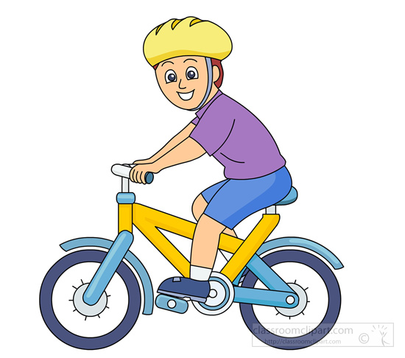
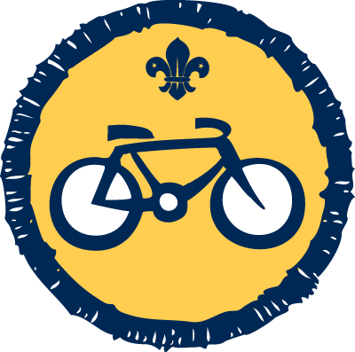
Requirements:
- Find out why it’s important to wear safety equipment
- Show how to put on and wear a cycle helmet correctly
- Show how to pump up a tyre
- Go for a short ride in a safe place
Completing the badge:
- For the first requirement, you could complete the attached work sheet. Alternatively you can create your own collage of bike safety equipment and note why each item is important.
- Your grown up can send videos of you showing your bike skills to a leader or take photographs for you to bring to our next meeting.
Cyclist Activity Badge
Cyclist Activity Badge Safety Sheet

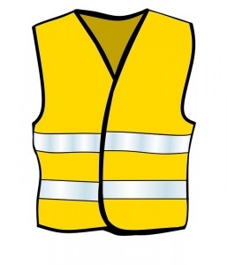
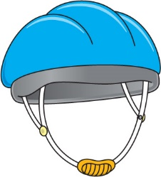
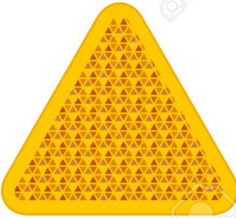
Write the names of the safety equipment in the boxes. Discuss with an adult how these items help to keep you safe.

Colour in the correct answer:
Which shoes would be safest to wear whilst riding your bike?

What kind of clothing is safest (colour more than one answer)?
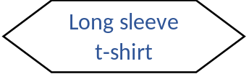

Dark Colours
Bright Colours
Wizards Cloak
Jumper
Shorts
Short sleeve t-shirt
Long trousers
Sandals
Trainers
Wellington Boots
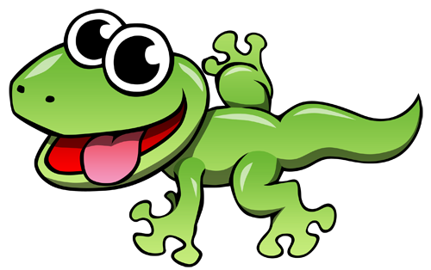

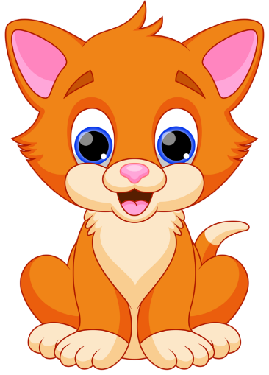

Requirements:
- Learn how to care for an animal, Find out what the animal needs. Learn about its habitat, space, exercise and sleeping area.
- Help to take care of that animal for four weeks
- Keep a note of how you have looked after the animal for the four weeks.
- Tell others in your colony about the animal
Completing the badge:
- Even though there are lots of computer games and things that show you what its like to care for an animal, these won’t count for the badge. You will need to learn to take care of a real, live animal
- You can include looking after wild animals such as birds for this badge if you do not have a pet at home. Caring for them would include feeding them and looking after a bird bath for example
- Keeping a note of how you have taken care of the animal could include takings photographs or writing short sentences. You can show us this at our next meeting.
Animal Friend Activity Badge

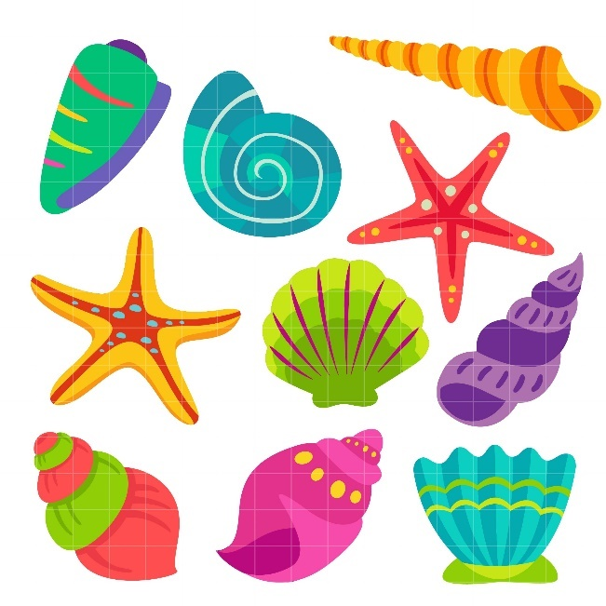

Requirements:
- Spend at least 6 weeks making a collection
- Show your colony a sample of things from your collection
- Tell others in your colony about your collection
Completing the badge:
- Build up your collection over 6 weeks (or longer), then choose some items to bring to Beavers.
- We would love to hear about what your collection is, why you collect them and what your favourite part from your collection is.
- Examples of collections:
  - Stickers or Cards
  - Items from nature such as shells or rocks
  - Awards from activities you’ve done such as badges or medals
  - Souvenirs from places you’ve visited such as postcards, magnets or keyrings
Collectors Activity Badge


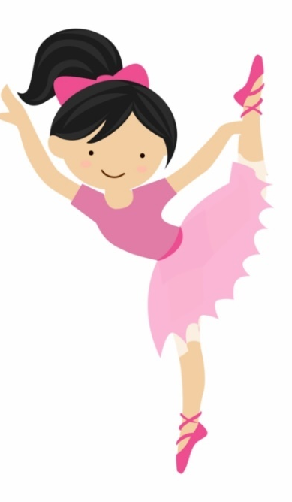
Requirements:
- Choose a hobby to take part in for at least 6 weeks.
- Show that you have stuck with your new hobby. Show that you know about your hobby and the skills you have learned.
- Show and tell your colony or your leaders about your chosen hobby. Talk about what it is, why you enjoy it and what your favourite thing about it is.
Completing the badge:
- Your hobby could be anything from Karate to Dancing, Go Karting to Painting! It is an activity done regularly in your free time for enjoyment
- Once you’ve decided what your hobby is, you should take part in it for at least 6 weeks
- You can show us what you have learned with photographs (you could create a collage to present at Beavers!) or videos, or depending on your hobby, you could demonstrate to us what it is!
Hobbies Activity Badge

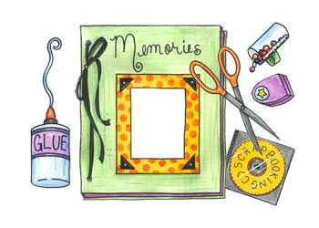

Requirements:
- Show someone how you use a camera to take a good photograph
- Take at least 10 photographs yourself.
- Tell someone why you like these photos or why you took them.
- Make something using photos you have taken.
Completing the badge:
- You can use a digital camera, disposable camera or even borrow a mobile phone with a camera
- The photographs need to have been taken by you. They could all be taken with the same theme for example:
  - Outdoors
  - Your family
  - Animals
  - Places you like to visit
- They could be 10 completely random photos taken just because you like them!
- Talk about your photos with a grown up, say why you took them and what you like about them
- Make something with the photos you have taken. This could be a:
  - Card
  - Poster
  - Calendar
  - Scrapbook
  - Slideshow
Photographer Activity Badge

